BDO India LLP
“AS IS” Analysis of Beneficiary Management System: 1.Executive Summary 2.Process Description 3.Pain Points & Bottlenecks Recording Period: 12th September 2025 to 17th September 2025
U.P. State Rural Livelihood Mission (PRERNA) Lucknow, Uttar Pradesh

Document Details
Project Name | As-Is Process Study-UPSRLM Enterprise Promotion Scheme
Date: | 12-09-2025 | Release | Ver 1.0
Author | Ayush M Srivastava, Haripriya Sharma
Owner | BDO India LLP
Client | U.P. State Rural Livelihood Mission (PRERNA)
Document Number | BDO-UPSRLM-AIPS-v1-BMS’2025

Approvals
Name | Title | Date of Issue | Version
Sachin A Kumar | Project Manager | 17-09-2025 | 1.0
Team BDO |  |  | 1.0

Distribution
Name | Title | Date of Issue | Version
Ms. Deepa Ranjan | Mission Director (MD), UPSRLM | 17-09-2025 | 1.0
Mr. Niti Shrivastav | Joint Mission Director (JMD), UPSRLM | 17-09-2025 | 1.0

Table of Contents
1. Executive Summary 4
1.1. Schematic Workflow Delegation of UPSRLM Beneficiary Management System 5
1.2. Beneficiary geographical Map 6
2. INTRODUCTION & SCOPE 7
2.1. Initiative Overview: Beneficiary Management System 7
2.2. Audit Objective: 7
2.3 Scope of Analysis 7
2.3.1. CRP & Field-Level Activities 8
2.3.2 Beneficiary & Household Data 8
2.3.3 Institutional Progression & Linkage 8
2.3.4 Audit-Analysis Map 8
3. Current Process Description 9
3.1. The Four Stages of Lifecycle 9
2.3.5 Community-Level Planning (SHG → VO) 9
2.3.6 Cluster-Level Consolidation & Strategy (CLF) 9
2.3.7 District-Level Review & Finalization (DMMU) 9
2.3.8 State-Level Approval & Fund Flow (SMMU + FMTSA) 9
3.2. Organizational Levels Involved 10
3.3. Identified Delays in AAP Process 10
3.4. Enterprise related Process Map 12
4. Identified Pain Points & Bottlenecks 13
4.1. Data Fragmentation & Lack of Integration 13
4.2. Inconsistent & Error‑Prone Data Capture 13
4.3. Delays in Planning & Approval Cycle 13
I. VO planning delays: VO EC coordination and data collection from SHGs is slow, especially in villages with poor connectivity or high geographical dispersion. 13
II. CLF VMOSA delays: The visioning and strategic planning process at CLF level is time‑intensive and often delayed due to unavailability of external facilitators or repeated revision cycles. 13
III. SMMU approval delays: SMMU approval of district AAPs takes extended time (often beyond March) due to coordination with government planning departments or policy changes, pushing implementation timelines. 13
4.4. Weak Real‑Time Monitoring & Review 13
4.5. Bottleneck Map 14
5. SWOT Analysis 15
5.1. Strengths 15
5.2. Weaknesses 15
5.3. Opportunities 15
5.4. Threats 16
6. Conclusion 17
6.1. Key challenges identified include: 17

- Executive Summary
UPSRLM Beneficiary Management System identifies rural poor households, forms SHGs, and tracks federations (VOs/CLFs) via NRLM MIS across UP hierarchy.
The report covers two primary workflows:
1. Annual Action Plan (AAP) Workflow - Strategic planning and budgetary processes for beneficiary outreach and services
2. SHG Member Becoming Workflow - How rural poor women are identified and inducted into SHGs
Recording Period:
12th September 2025 to 17th September 2025

Level | Key Roles & Responsibilities
SMMU | SMM: Inclusion guidelines/MIS  Specialist: SC/ST targeting  Finance: Budgets/funds
DMMU | DMM: Campaigns/data validation  Coordinator: PIP/exclusions  MIS: Data entry/reporting
BMMU | BMM: SHG/VO operations  CRPs: Surveys/SHG formation  Operator: Data entry
Community | CRPs: Mobilization/training  Bookkeepers: Records  VO/CLF: Service linkages

Hierarchy: State-District-Block-SHG/VO/CLF mapping for aggregation; limited individual filters.
Powers: Delegated to DMMU/BMMU for efficiency; SMMU retains surveys/standards; FMTSA handles finances.

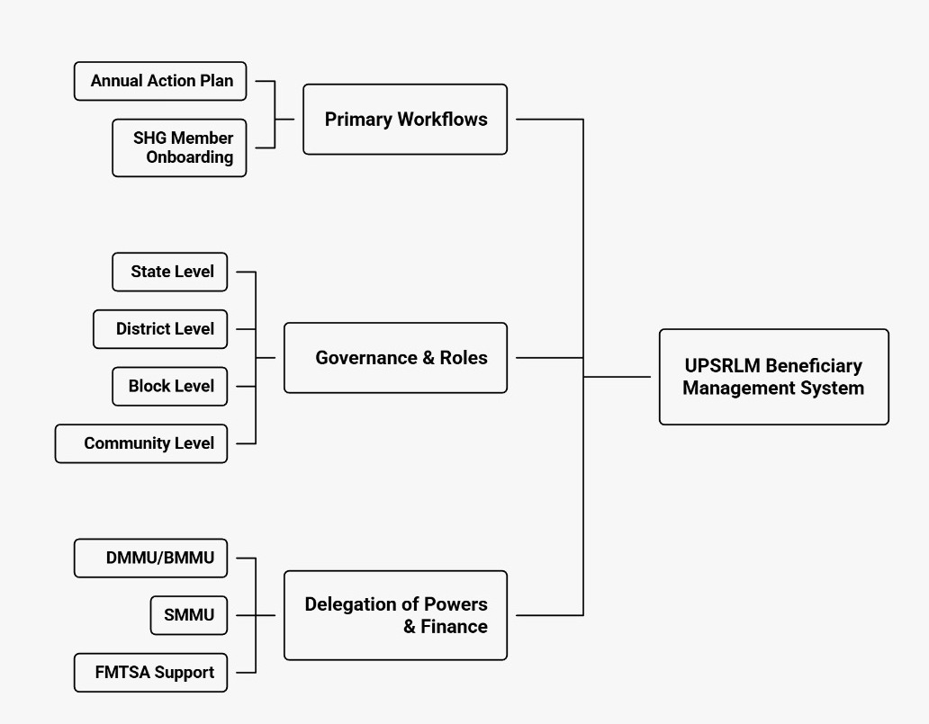
  - Schematic Workflow Delegation of UPSRLM Beneficiary Management System

  - Beneficiary geographical Map
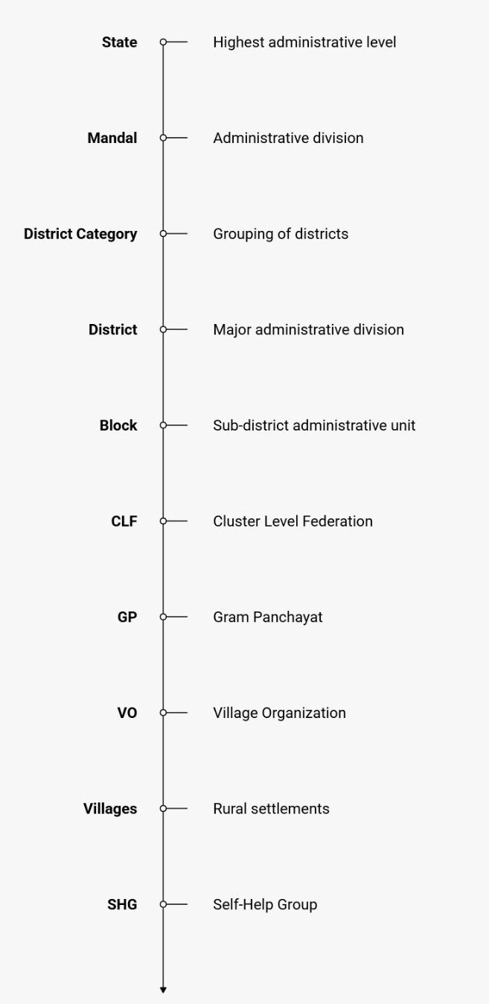
- INTRODUCTION & SCOPE
The initiative moves beyond beneficiary participation and deliberately positions women as enterprise leaders, to understand beneficiary management workflows, it is essential to describe the three tiers of community institutions that organize and represent beneficiaries within the NRLM architecture. The Uttar Pradesh State Rural Livelihood Mission (UPSRLM) uses a structured institutional framework – SHG–VO–CLF – to systematically identify rural poor households, mobilize eligible women into Self Help Groups (SHGs), and track their progression across federated institutions and financial inclusion services.
Within DAY‑NRLM, UPSRLM leverages a centralized Management Information System (MIS) to ensure that each beneficiary is linked to a household, an SHG, and higher-level federations (VOs, CLFs), enabling the delivery and monitoring of government benefits and livelihood interventions. This AS‑IS report maps the current beneficiary-related processes from social inclusion and SHG formation to federating into Village Organizations (VOs) and Cluster Level Federations (CLFs), and their reflection in NRLM databases across the full geographical hierarchy used in Uttar Pradesh.

  - Initiative Overview: Beneficiary Management System
The Beneficiary Management System under Uttar Pradesh State Rural Livelihood Mission (UPSRLM) is the core mechanism to systematically identify rural poor households, mobilize eligible women into Self Help Groups (SHGs), and track their progression across federated community institutions (VOs, CLFs) and financial inclusion services.
Within DAY‑NRLM, UPSRLM uses a structured institutional architecture and centralized MIS to ensure that each beneficiary is linked to a household, an SHG, and higher-level federations. This linkage enables the delivery and monitoring of government benefits, livelihood interventions, and financial services across the mission’s geographical hierarchy in Uttar Pradesh.

  - Audit Objective:
- The primary objective of this analysis is to conduct a comprehensive audit of existing beneficiary management practices across field, block, and district levels. This audit aims to:

- Justify the Transition: Generate evidence-based justification for moving towards a structured and digitized Beneficiary Management System (BMS) integrated with NRLM MIS.

- Eradicate Informalism: Eliminate reliance on verbal-only reporting, ad-hoc registers, and informal word-of-mouth communication channels in beneficiary identification, SHG formation, and federation processes.

- Standardize Data Capture: Establish uniform protocols for how beneficiary and household information is collected by CRPs/field staff, verified by BMMs, and monitored by DMMs.

- Strengthen Accountability: Introduce traceability and ownership at each data handoff point – from household profiling to SHG/VO/CLF formation and linkage to schemes and banks.

2.3 Scope of Analysis
The audit focuses on three critical touchpoints where data integrity, accuracy, and timeliness are currently most at risk:

2.3.1. CRP & Field-Level Activities
- Assessment of field-level data capture practices, including manual registers, non-standard formats, and reporting frequency for:

  - Household profiling and vulnerability assessment.

  - SHG formation and member on boarding.

  - VO/CLF federation and office bearer records.
    - Beneficiary & Household Data
- Evaluation of how beneficiary and household information is:

  - Manually recorded (name, gender, social category, SECC/PIP status, bank linkage).

  - Re-entered and consolidated at block and district levels.

  - Reflected in NRLM MIS and used for AAP, fund allocation, and scheme targeting.
    - Institutional Progression & Linkage
- Analysis of how progression from SHG to VO to CLF is documented and validated, including:

  - Formation of VOs/CLFs and election of office bearers.

  - Bank and financial linkage (SHG, VO, CLF accounts).

  - Linkage to government schemes and livelihood programs.

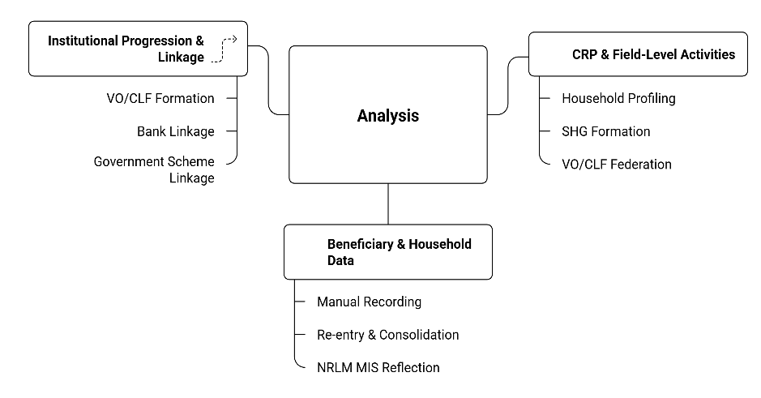
    - Audit-Analysis Map
- Current Process Description
The current beneficiary management process in UPSRLM follows a structured, multi-level planning and budgeting cycle, where targets for SHG formation, member inclusion, and service delivery are defined at the community level and progressively consolidated up to the state level. This process is supported by digital modules for SHG/VO/CLF, Aadhaar, bank linkage, and loan tracking, but these remain fragmented and lack a centralized analytics layer for real‑time review.
  - The Four Stages of Lifecycle
    - Community-Level Planning (SHG → VO)

SHG members assess their group’s strength, identify need for new members, and evaluate capacity for trainings and livelihood support.

VO Executive Committee (EC) collects plans from member SHGs, consolidates coverage gaps (left-out poor), and identifies service demands (training, credit, enterprise support).

VO finalizes a plan document with targets for new SHGs/members, service delivery, convergence with government schemes, and budget requirements.

Key Actors: SHG Members, VO EC, VO President, VO Secretary
    - Cluster-Level Consolidation & Strategy (CLF)

At the cluster level, VO plans are aggregated and aligned with CLF-level strategy:

CLF receives consolidated VO plans and prepares for aggregation at the district level.

CLF EC and member VO representatives conduct VMOSA (Vision, Mission, Objectives, Strategy, Activities) planning to align VO plans with CLF goals (enterprise targets, market linkages, sustainability).

CLF Nodal Officer and Secretary aggregate all VO targets and prepare a district-level plan with projected reach, beneficiaries, and service targets.

Key Actors: CLF President, CLF Nodal Officer, CLF EC, CLF Secretary
    - District-Level Review & Finalization (DMMU)

At the district level, plans are reviewed and finalized into the Annual Action Plan (AAP):

- DMM and DMMU team review CLF plans against district targets and government priorities, with focus on backward blocks and vulnerable groups.
- DMM and district planning team finalize the District AAP with beneficiary targets, resource requirements, convergence linkages, and district-level budget.
- Key Actors: DMM, DMMU Team, DMM Planning Team

    - State-Level Approval & Fund Flow (SMMU + FMTSA)

At the state level, district AAPs are approved and funds are released for implementation:

- SMMU and state planners review all district AAPs for consistency, alignment with state priorities, and feasibility.
- SMMU Director takes the decision to approve the AAP or return it for revision.
- If not approved, the district team revises the AAP based on SMMU feedback and resubmits it.
- Once approved, the AAP is officially shared with blocks for implementation.
- FMTSA and state finance allocate beneficiary service budget to districts based on approved targets (SHG formation, capacity building, RF, CIF, etc.).
- Funds are transferred to district accounts through PFMS, cascaded to blocks, and implementation begins at the block level.
- Key Actors: SMMU, State Planners, SMMU Director, FMTSA, State Finance, DMM, DMMU Finance, BMM, BMMU, Community Institutions

  - Organizational Levels Involved
- Village Organizations (VOs)
- Block Mission Management Unit (BMMU)
- District Mission Management Unit (DMMU)
- State Mission Management Unit (SMMU)
- Financial Management Technical Support Agency (FMTSA)

  - Identified Delays in AAP Process
- VO Planning Delays: Delays in VO EC member coordination and data collection from member SHGs, especially in villages with poor road connectivity or high geographical dispersion.
- CLF VMOSA Facilitation Delays: Time-intensive visioning and strategic planning process, often delayed due to unavailability of external facilitators or repeated revision cycles.
- SMMU Approval Turnaround: SMMU approval of district AAPs often takes extended time (beyond March) due to coordination with government planning departments or policy changes.

Stage | Level | Key Steps | Key Actors | Identified Delays / Risks
I. Community-Level Planning  (SHG → VO) | Village / VO | 1. SHG members assess group strength, identify need for new members, and evaluate capacity for trainings and livelihood support.  2. VO EC collects plans from member SHGs, consolidates coverage gaps (left-out poor), and identifies service demands (training, credit, enterprise support).  3. VO finalizes plan with targets for new SHGs/members, service delivery, convergence, and budget requirements. | - SHG Members  - VO EC  - VO President  - VO Secretary | VO Planning Delays  Delays in VO EC coordination and data collection from SHGs, especially in villages with poor connectivity or high dispersion.
II. Cluster-Level Consolidation & Strategy  (CLF) | Cluster / CLF | 1. CLF receives consolidated VO plans and prepares for aggregation at district level.  2. CLF EC and member VO representatives conduct VMOSA (Vision, Mission, Objectives, Strategy, Activities) planning to align VO plans with CLF goals (enterprise, market linkages, sustainability).  3. CLF Nodal Officer and Secretary aggregate VO targets and prepare district-level plan (reach, beneficiaries, service targets). | - CLF President  - CLF Nodal Officer  - CLF EC  - CLF Secretary | CLF VMOSA Facilitation Delays  Time-intensive visioning and strategic planning, often delayed due to unavailability of external facilitators or repeated revision cycles.
III. District-Level Review & Finalization  (DMMU) | District / DMMU | 1. DMM and DMMU team review CLF plans against district targets and government priorities (focus on backward blocks, vulnerable groups).  2. DMM and district planning team finalize District Annual Action Plan (AAP) with:  - Beneficiary targets  - Resource requirements  - Convergence linkages  - District-level budget. | - DMM  - DMMU Team  - DMM Planning Team | –
IV. State-Level Approval & Fund Flow  (SMMU + FMTSA) | State / SMMU | 1. SMMU and state planners review all district AAPs for consistency, alignment with state priorities, and feasibility.  2. SMMU Director decides: AAP approved or to be revised.  3. If not approved, district team revises AAP and resubmits.  4. Once approved, AAP is officially shared with blocks for implementation.  5. FMTSA and state finance allocate beneficiary service budget to districts (SHG formation, capacity building, RF, CIF, etc.).  6. Funds transferred to district accounts via PFMS, cascaded to blocks.  7. Implementation begins at block level (SHG formation, member inclusion, service delivery). | - SMMU  - State Planners  - SMMU Director  - FMTSA  - State Finance  - DMM  - DMMU Finance  - BMM  - BMMU  - Community Institutions | SMMU Approval Turnaround  SMMU approval of district AAPs often takes extended time (beyond March) due to coordination with government planning departments or policy changes.

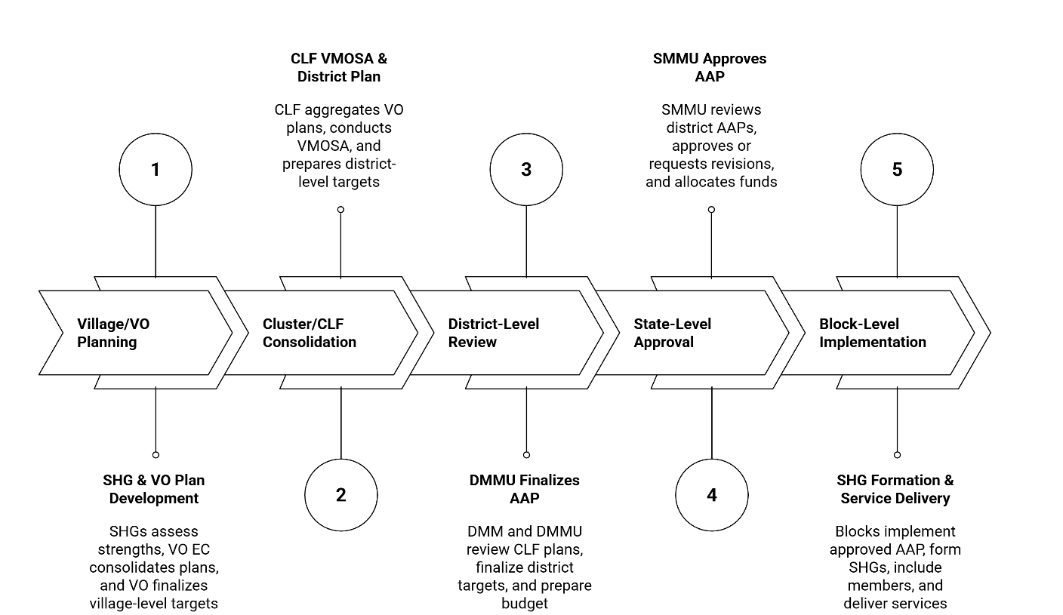
  - Enterprise related Process Map
- Identified Pain Points & Bottlenecks
  - Data Fragmentation & Lack of Integration
- Multiple disconnected modules: SHG/VO/CLF, Aadhaar, bank linkage, and loan repayment are captured in separate systems, but there is no single integrated beneficiary profile.
- No central analytics layer: No unified dashboard exists to show real‑time status of SHGs, members, Aadhaar seeding, bank linkage, and loan repayment at block/district level.
- Manual consolidation required: For planning and review, staff must pull data from multiple modules and bank statements, leading to delays and inconsistent reporting.
  - Inconsistent & Error‑Prone Data Capture
- No standardized validation at entry: Data is captured in non‑standard formats across blocks; Aadhaar and bank details are often missing, mismatched, or inconsistently entered.
- High risk of duplication and errors: Same beneficiary data is entered multiple times in different modules, increasing the chance of duplication and transcription errors.
- Dependence on individual cadre: Data quality depends heavily on the diligence and understanding of CRPs and community cadres, leading to variability across blocks.
  - Delays in Planning & Approval Cycle

VO planning delays: VO EC coordination and data collection from SHGs is slow, especially in villages with poor connectivity or high geographical dispersion.

CLF VMOSA delays: The visioning and strategic planning process at CLF level is time‑intensive and often delayed due to unavailability of external facilitators or repeated revision cycles.

SMMU approval delays: SMMU approval of district AAPs takes extended time (often beyond March) due to coordination with government planning departments or policy changes, pushing implementation timelines.
  - Weak Real‑Time Monitoring & Review
- No live dashboards for review: Block and district managers cannot quickly see which SHGs/VOs are active vs dormant, which beneficiaries are missing Aadhaar or bank linkage, or which loans are overdue.
- Reactive decision‑making: Without automated aggregation, decisions on beneficiary targeting, fund allocation, and service delivery remain reactive and largely manual.
- Limited visibility into loan repayment: Loan repayment status is not updated in real time; field staff often rely on bank passbooks or verbal confirmation, increasing risk of default.

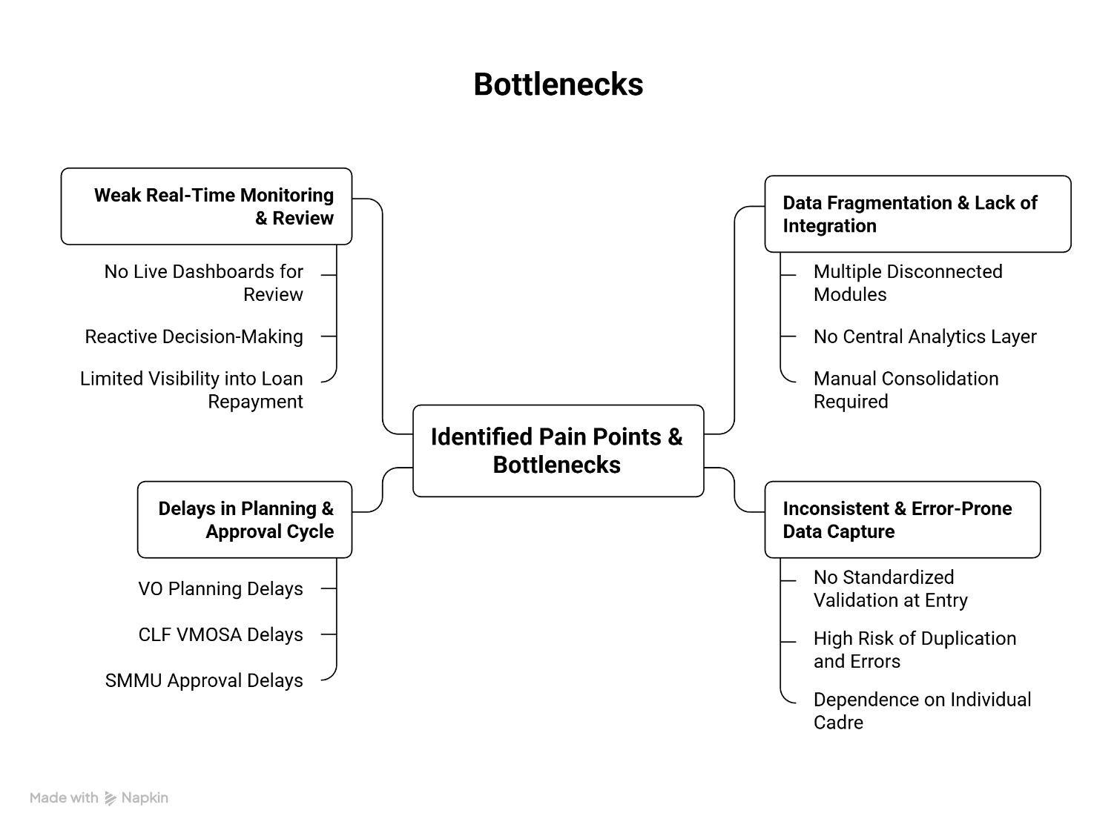
  - Bottleneck Map
- SWOT Analysis
  - Strengths
- Structured institutional architecture (SHG → VO → CLF) that clearly defines beneficiary progression and roles.
- Centralized MIS that links each beneficiary to household, SHG, and higher federations for tracking benefits and services.
- Participatory planning process at community level (SHG/VO) that ensures grassroots ownership of targets and service needs.
- Standardized workflows for AAP, SHG formation, and federation that are documented and followed across levels.
- Multi‑level governance (SMMU–DMMU–BMMU–VO–CLF) with clear roles for planning, review, and fund flow.
- Use of digital modules for SHG/VO/CLF, Aadhaar, bank linkage, and loan tracking, reducing reliance on purely paper‑based systems.
- Clear fund flow mechanism from SMMU → FMTSA → PFMS → District → Block → Implementation.
  - Weaknesses
- Fragmented data systems: SHG/VO/CLF, Aadhaar, bank linkage, and loan data exist in separate modules with no single integrated beneficiary profile.
- No central analytics layer: No unified dashboard for real‑time monitoring of SHGs, members, Aadhaar, bank linkage, and loan repayment at block/district level.
- Manual consolidation & reporting: Staff must manually pull data from multiple modules and bank statements, leading to delays and inconsistent reporting.
- Inconsistent data capture: No standardized validation at entry; Aadhaar and bank details are often missing, mismatched, or inconsistently entered across blocks.
- High risk of duplication and errors: Same beneficiary data is entered multiple times in different modules, increasing duplication and transcription errors.
- Dependence on individual cadre: Data quality depends heavily on the diligence and understanding of CRPs and community cadres, leading to variability across blocks.
- Weak real‑time monitoring: No live dashboards to track active/dormant SHGs/VOs, missing Aadhaar/bank linkage, or overdue loans.
  - Opportunities
- Integrate all modules (SHG/VO/CLF, Aadhaar, bank, loan) into a unified Beneficiary Management System (BMS).
- Develop real‑time dashboards at block/district/state level for SHG/VO/CLF formation, member inclusion, Aadhaar, bank linkage, and loan repayment.
- Standardize data capture protocols across blocks with validation rules for Aadhaar, bank details, and social category at the point of entry.
- Automate AAP workflows (VO → CLF → DMMU → SMMU) with digital forms, approvals, and fund allocation triggers.
- Enable data‑driven decision‑making for beneficiary targeting, fund allocation, and service delivery using live dashboards.
- Improve linkage to government schemes and livelihood programs using a unified beneficiary profile for convergence and eligibility checks.
- Scale the same BMS architecture to other rural livelihood and social protection schemes.
  - Threats
- Delays in planning & approval cycle: VO planning, CLF VMOSA, and SMMU approval delays push implementation timelines, affecting timely service delivery.
- Operational bottlenecks in fund flow: Delays in allocation and transfer of funds through FMTSA and PFMS directly impact SHG formation and service delivery at block level.
- Governance & accountability gaps: No clear traceability or ownership at each data handoff point, making it hard to track errors or delays.
- Capacity & process bottlenecks: Over‑reliance on external facilitators for CLF VMOSA and VO planning; any unavailability stalls the entire planning cycle.
- Fragmented responsibility: Different teams own different modules (SHG, Aadhaar, loan, bank), but no single owner for the end‑to‑end beneficiary journey, leading to finger‑pointing.
- Reactive decision‑making: Without automated aggregation, decisions on beneficiary targeting, fund allocation, and service delivery remain reactive and largely manual.
- Risk of default and poor recovery: Limited visibility into loan repayment status increases the risk of overdue loans and poor recovery at SHG/VO/CLF level.
- Conclusion
The current operational framework for managing beneficiary data in UPSRLM follows a structured, multi-level planning and implementation cycle, but remains heavily dependent on fragmented digital modules and manual processes at field, block, and district levels. While the mission has a strong institutional architecture (SHG–VO–CLF), centralized MIS, and standardized workflows for AAP and SHG on boarding, these strengths are undermined by systemic inefficiencies in data management and decision-making.

  - Key challenges identified include:

- Data fragmentation: SHG/VO/CLF, Aadhaar, bank linkage, and loan data are captured in separate modules with no single integrated beneficiary profile, leading to duplication, inconsistent formats, and manual consolidation.
- Weak data integrity: Absence of standardized validation at entry results in missing or mismatched Aadhaar and bank details, high error rates, and dependence on individual cadre diligence, causing variability across blocks.
- Delays in planning and approval: VO planning, CLF VMOSA, and SMMU approval cycles are time-intensive and often delayed, pushing back AAP finalization and fund release, which in turn delays implementation at the block level.
- Poor real-time monitoring: No centralized analytics layer or live dashboards exist to track SHG/VO/CLF formation, member inclusion, Aadhaar seeding, bank linkage, and loan repayment, forcing managers to rely on outdated, manually consolidated reports.
- Reactive decision-making: Without automated aggregation and traceability, decisions on beneficiary targeting, fund allocation, and service delivery remain reactive, increasing the risk of misaligned support and poor recovery on loans.
- Despite these bottlenecks, the system demonstrates important strengths:
- A well-defined, participatory planning process at community level (SHG/VO) that ensures grassroots ownership of targets and service needs.
- Clear multi-level governance (SMMU–DMMU–BMMU–VO–CLF) with defined roles for planning, review, and fund flow.
- Use of digital modules for SHG/VO/CLF, Aadhaar, and bank linkage, which provides a foundation for integration and automation.
- A robust fund flow mechanism from SMMU → FMTSA → PFMS → District → Block → Implementation, which can be leveraged for timely service delivery when supported by accurate data.
- Opportunities exist to transform this hybrid, fragmented system into a unified, digitized Beneficiary Management System (BMS) that:
- Integrates all modules (SHG/VO/CLF, Aadhaar, bank, loan) into a single platform with a unified beneficiary profile.
- Introduces real-time dashboards at block/district/state level for monitoring SHG/VO/CLF formation, member inclusion, Aadhaar, bank linkage, and loan repayment.
- Standardizes data capture protocols with validation rules at entry and automates AAP workflows (VO → CLF → DMMU → SMMU) with digital forms and approvals.
- Enables data-driven decision-making for beneficiary targeting, fund allocation, and linkage to government schemes and livelihood programs.
- The threats of continuing with the current fragmented approach are significant:
- Delays in planning and approval cycles will continue to push implementation timelines, reducing the impact of timely interventions.
- Operational bottlenecks in fund flow and fragmented responsibility will lead to misallocation of resources and finger-pointing across teams.
- Weak real-time monitoring and reactive decision-making will increase the risk of overdue loans and poor recovery at SHG/VO/CLF level.
- Without a clear traceability and ownership model, accountability for data quality and service delivery will remain weak.
- Recommendation: Transitioning to a structured, integrated, and digitized Beneficiary Management System (BMS) is critical to address these gaps. A digital BMS would ensure:
- Centralized, secure storage of beneficiary and household data with a single source of truth.
- Real-time tracking of beneficiary progression (SHG → VO → CLF), Aadhaar seeding, bank linkage, and loan utilization/repayment.
- Reduction in duplication, errors, and reporting delays through standardized capture and automated validation.
- Enhanced supervisory oversight and data-driven decision-making at all levels (block, district, state).

In conclusion, modernizing the beneficiary management workflow is no longer optional—it is essential for ensuring the mission’s efficiency, accountability, and long-term sustainability. The adoption of a digital BMS will transform current fragmented, manual practices into a robust, scalable, and transparent system capable of supporting UPSRLM’s strategic objectives and improving outcomes for rural poor households and women entrepreneurs.

Disclaimer
- By reading the report, the reader accepts the terms and conditions mentioned hereunder.
- The scope of assignment is as per the agreement between BDO India LLP (“Consultant” or “we”) and Uttar Pradesh State Rural Livelihood Mission (UPSRLM) for the project Beneficiary Management System.
- This Report (“Report”) is prepared solely for UPSRLM. This Report is intended for UPSRLM’s internal use only and may not be relied upon by other parties (“Third Party”). Neither this Report nor its contents may be distributed to, discussed with, or otherwise disclosed to any Third Party without the prior written consent of BDO India LLP. Any other persons who choose to rely on these observations may do so entirely at their own risk.
- Our procedures and findings are based solely on the data, documentation, information, and explanations provided to us during the course of our engagement. In case we come across information which may have a bearing on the findings and observations made in this Report subsequent to the submission of the Report, we have no responsibility to update this Report. In circumstances where any additional information becomes available from or with respect to the engagement to us, we would be glad to carry out additional procedures as may be separately agreed with the Client.
- The work carried out and analysis presented in this Report are based on the results of our discussions with representatives of UPSRLM and are not always supported by written documentation. We make no representation regarding the sufficiency of the procedures performed either for the purpose for which this engagement was sought or for any other purpose. Findings are based on circumstantial evidence and may be partially concluded in the absence of adequate supporting documents.
- We have relied on the information provided by UPSRLM and its field representatives; our observations are based primarily on the review of such information. In respect of information received in soft copy or unverified digital formats, no independent verification with original documents has been carried out.
- This Report does not constitute an engagement to provide audit, compilation, review, or attestation services made in accordance with the generally accepted auditing standards in India and, consequently, no assurance will be expressed. Our work does not represent an expression of an opinion or testimony of an expert witness. Further, the engagement does not extend to providing advice, analysis, or observations relating to legal and regulatory issues.
- In no circumstances shall we be liable for any loss or damage, of whatsoever nature, arising from information material to our work being withheld, concealed, or misrepresented to us by any person at the state, district, or field level from whom information was requested.
- BDO India LLP has executed detailed work steps as identified and agreed in the scope of work.
- We assume no responsibility for the accuracy and completeness of the information, recognizing that cost/benefit and other considerations will preclude us from pursuing every conceivable source of information. We have used professional judgment to identify the information sources to be reviewed. If other professionals undertook similar procedures on the same subjects, such professionals might arrive at different findings.
- UPSRLM shall be fully and solely responsible for applying independent judgment with respect to the findings included in this Report to make appropriate decisions regarding future courses of action. BDO India LLP shall not be responsible for the consequences resulting from decisions based on the information included in this Report.
- BDO India LLP has not identified, addressed, or corrected any errors or defects in computer systems, applications, or related components (“Systems”), whether arising from data entry, storage, interpretation, processing, or reporting. We shall not be responsible for any defect or problem arising out of or related to data processing in any Systems.
- Our reports and comments should not be considered a definitive pronouncement on any individual, system, or the Mission.
- When assisting the Client in the performance of activities, BDO India LLP has not:
- Determined which, if any, recommendations should be implemented;
- Acted on behalf of management in reporting to oversight committees;
- Taken custody of assets;
- Acted in any capacity equivalent to a member of management or an employee;
- Assessed the quality of source data provided by the field;
- Been held liable for any loss or damage, of whatsoever nature, arising from analysis.
- BDO India LLP has not approved, nor is responsible for, the overall risk assessment work, including the ultimate determination of project priorities or the frequency of performance of any future audit or review procedures.

WHAT MATTERS TO YOU,
MATTERS TO US.

FOR MORE INFORMATION:
Anurag Srivastava- Partner
+91 – 9717004947| AnuragSrivastava@bdo.in

BDO INDIA LLP, an Indian limited liability partnership, is a member of BDO International Limited, a UK company limited by guarantee, and forms part of the international BDO network of independent member firms.

BDO is the brand name for the BDO network and for each of the BDO Member Firms.
Copyright © Aug 2021, BDO INDIA LLP. All rights reserved.
www.bdo.in

